Fredy27 Documentation

**workflow project for Qwen Image Edit 2511**

**Fredy27OP *—* 1/25/26, 2:35 PM**

I started to create a workflow for QIE 2511 with automatic prompt selector

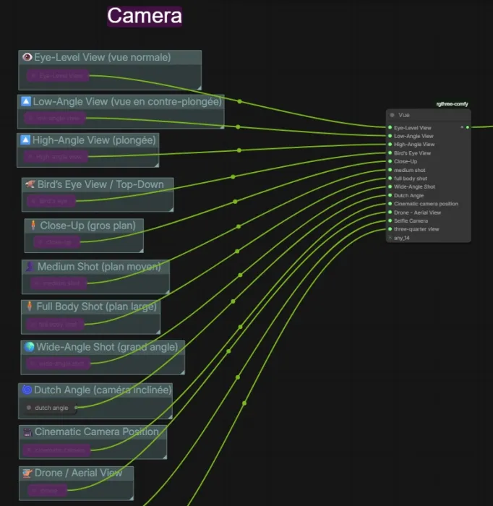

**Fredy27OP *—* 1/25/26, 2:37 PM**

subgraph for the concatened prompt used

Fast group bypasser generate for the camera position

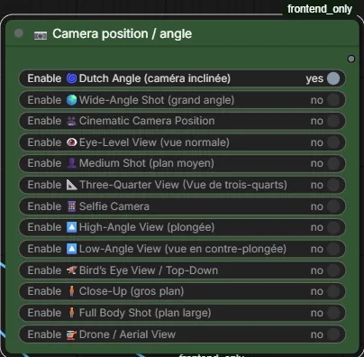

**Fredy27OP *—* 1/25/26, 5:50 PM**

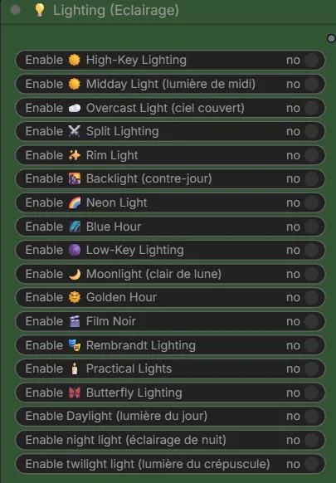

**D-EFFECTS *—* 1/25/26, 10:20 PM**

Are you gonna share the wf?

**Fredy27OP *—* 1/25/26, 10:58 PM**

the workflow is inside the pic !

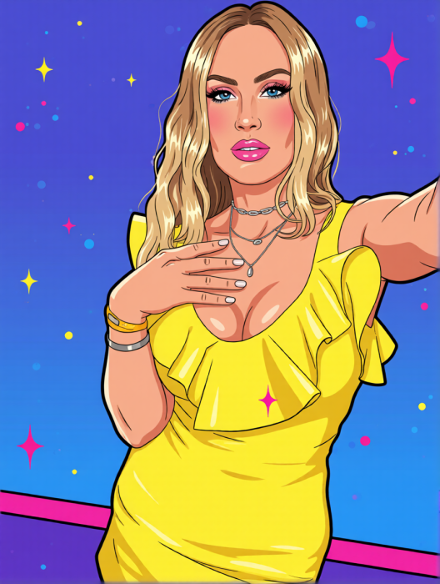

8 customs nodes used

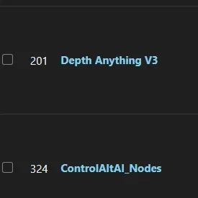

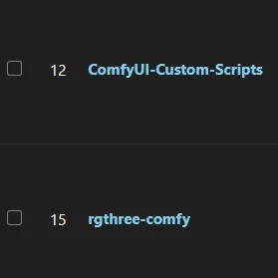

and the checkpoint Qwen-Image-Edit-Rapid-AIO (NSFW) v22 from Phr00t Hugging Face) based on Qwen Image Edit 2511

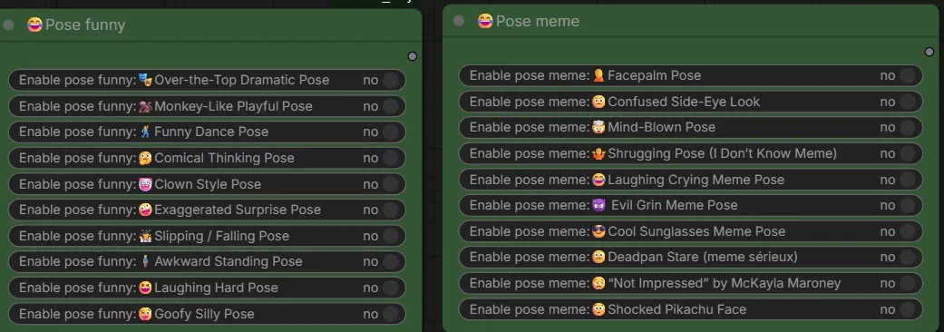

i add an auto-select resolution from image ref 1, 2, 3 or custom resolution or preset resolution (flux resolution calc)



**Fredy27OP *—* 1/25/26, 11:06 PM**

and control.net on image 2

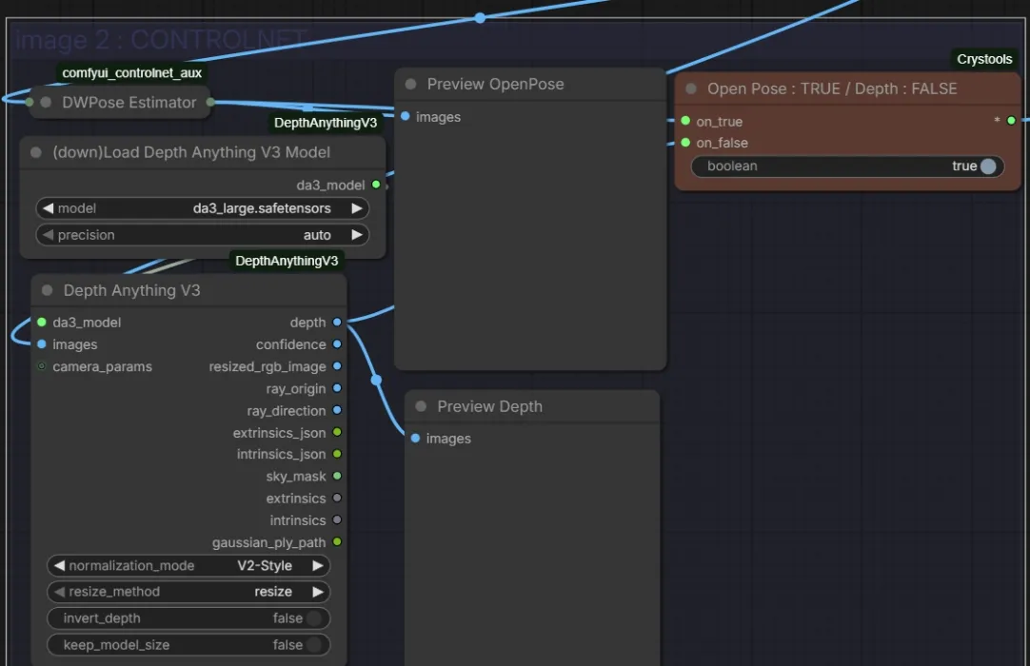

**D-EFFECTS *—* 1/26/26, 5:30 AM**



Thank you

**D-EFFECTS *—* 1/26/26, 7:41 AM**

This wf is awesome thank you. Just a pity that some is in French and I have no idea what they mean

**Fredy27OP *—* 1/26/26, 10:43 AM**

because i'm french !

**D-EFFECTS *—* 1/26/26, 10:43 AM**

yeah that was obvious

**Fredy27OP *—* 1/26/26, 10:54 AM**

any ideas of other type of prompts to add ?

**D-EFFECTS *—* 1/26/26, 1:14 PM**

As I use the wf and I think of something I'll let you know

**Fredy27OP *—* 1/26/26, 1:52 PM**

Image

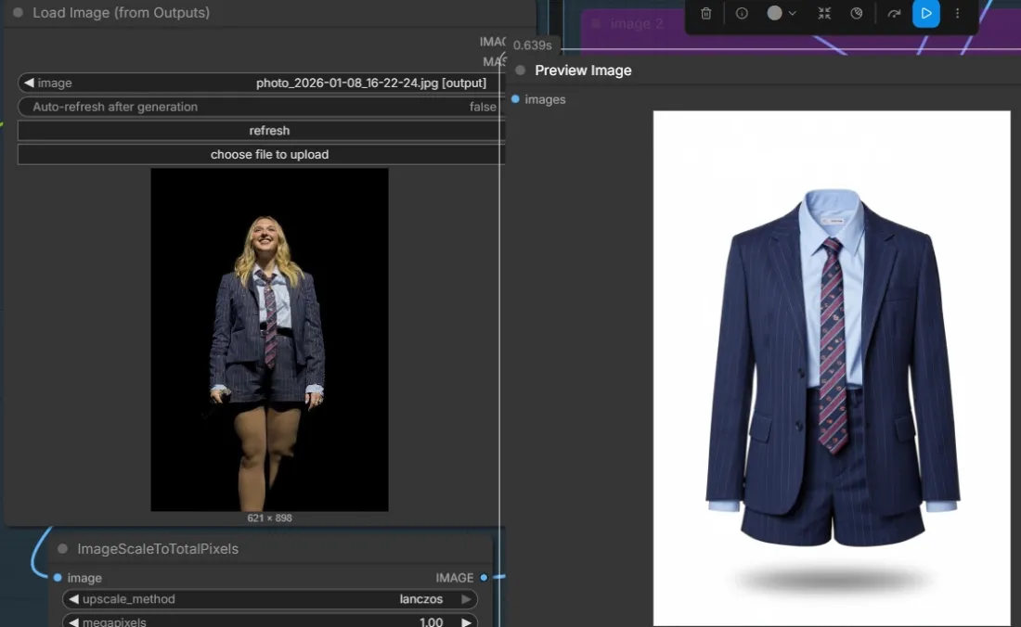

**Fredy27OP *—* 1/26/26, 2:02 PM**

result

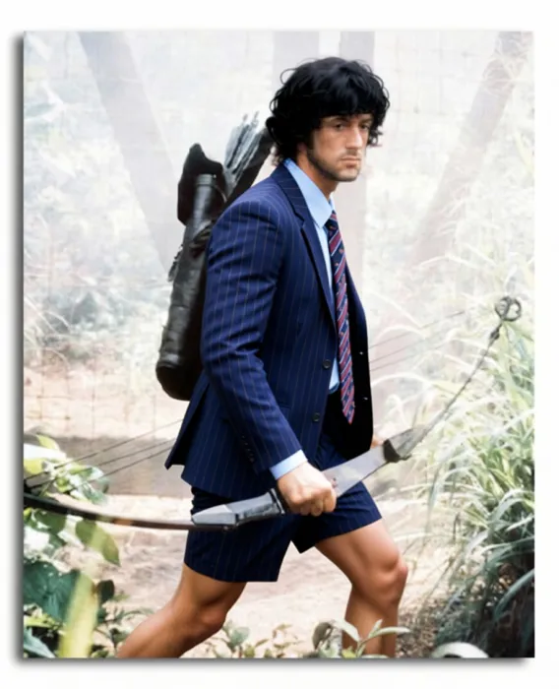

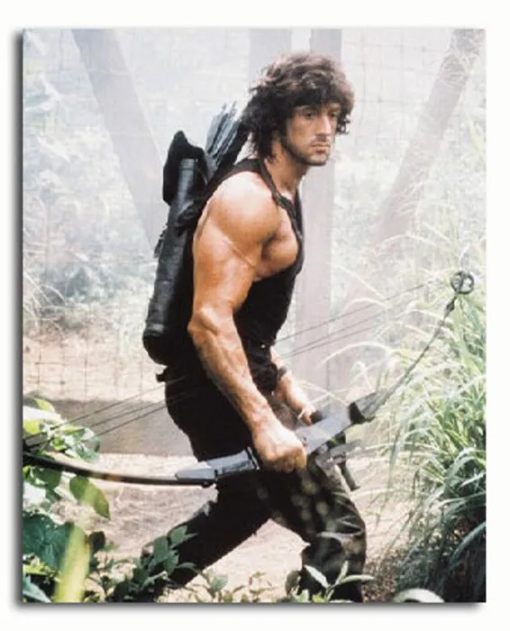

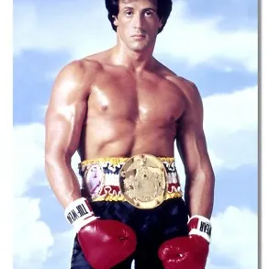

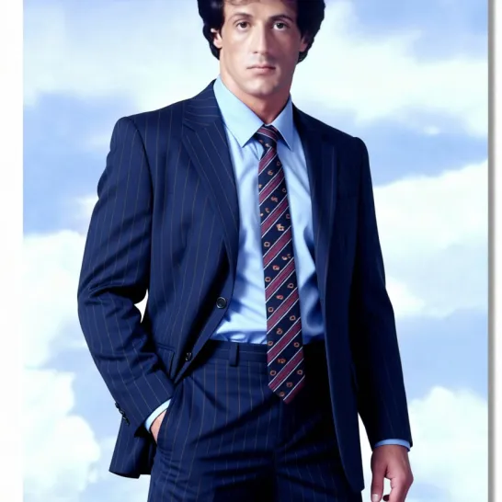

better with that simple prompt : only replace the clothes



**Fredy27OP *—* 1/26/26, 2:10 PM**



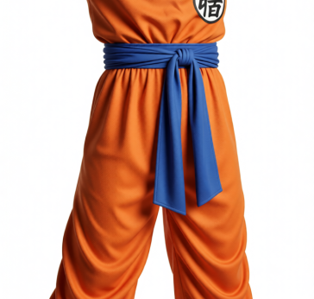



**KipCal *—* 1/26/26, 8:13 PM**

I can only assume I am doing something wrong, when I try to get the workflow, the image(s) save as a webp with no workflow. What am I doing wrong?

**Fredy27OP *—* 1/26/26, 8:14 PM**

dowloand the picture's girl

**KipCal *—* 1/26/26, 8:17 PM**

well, I am downloading the pictures, but discord has converted them all from png to webp, which strips out the workflows

So, I am still missing some step to get the png's rather than the webp

**KipCal *—* 1/26/26, 8:28 PM**

Well, had to get on the iOS app (was on a web browser/MacOS) ... and get the link for the real media file, and was able to get the png ... then came back and did a copy link from the page with the image on it on the web and was able to get it as well ... I was trying to download the displayed image, which was the webp

**KipCal *—* 1/26/26, 8:42 PM**

merci beaucoup

**Fredy27OP *—* 1/26/26, 10:46 PM**

Français ?

**KipCal *—* 1/26/26, 11:14 PM**

No, just an American living in The Netherlands. Your workflow is fantastic!

**MEE6APP *—* 1/26/26, 11:14 PM**

GG @KipCal, you just advanced to level 1!

**Fredy27OP *—* 1/26/26, 11:18 PM**

I will add specific group for select camera angle from the lora qwen image edit 2511 multi angles

**ScoobyAS *—* 2/2/26, 9:21 AM**

Hi Fredy27, what a nice workflow! THX for sharing! Did you already replace this depreciated node in your newest version and if so, may I asked you to (re-)share it?

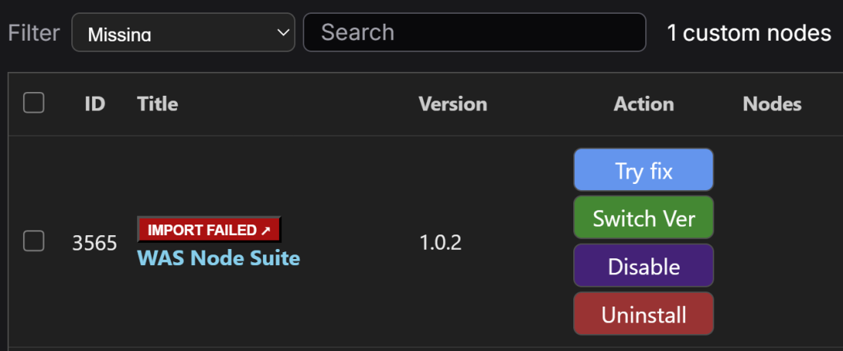

**Fredy27OP *—* 2/2/26, 10:17 AM**

done !

{"id":"c82f0925-5689-4ebb-9495-c787d121e42a","revision":0,"last_node_id":512,"last_link_id":786,"nodes":[{"id":70,"type":"FluxKontextMultiReferenceLatentMethod","pos":[-1661.5239044501195,-547.0181259460725],"size":[335.4380859375,58],"flags":{"collapsed":true},"order":61,"mode":0,"inputs":[{"localized_name":"conditioning","name":"conditioning","type":"CONDITIONING","link":186},{"localized_name":"reference_latents_method","name":"reference_latents_method","type":"COMBO","widget":{"name":"reference_latents_method"},"link":null}],"outputs":[{"localized_name":"CONDITIONING","name":"CONDITIONING","type":"CONDITIONING","links":[187]}],"properties":{"cnr_id":"comfy-core","ver":"0.5.1","Node name for S&R":"FluxKontextMultiReferenceLatentMethod","enableTabs":false,"tabWidth":65,"tabXOffset":10,"hasSecondTab":false,"secondTabText":"Send Back","secondTabOffset":80,"secondTabWidth":65,"ue_properties":{"widget_ue_connectable":{},"version":"7.5.2","input_ue_unconnectable":{}}},"widgets_values":["index_timestep_zero"],"color":"#222","bgcolor":"#000"},{"id":71,"type":"FluxKontextMultiReferenceLatentMethod","pos":[-1664.9378308025025,-531.6532511675115],"size":[335.4380859375,58],"flags":{"collapsed":true},"order":59,"mode":0,"inputs":[{"localized_name":"conditioning","name":"conditioning","type":"CONDITIONING","link":188},{"localized_name":"reference_latents_method","name":"reference_latents_method","type":"COMBO","widget":{"name":"reference_latents_method"},"link":null}],"outputs":[{"localized_name":"CONDITIONING","name":"CONDITIONING","type":"CONDITIONING","links":[189]}],"properties":{"cnr_id":"comfy-core","ver":"0.5.1","Node name for S&R":"FluxKontextMultiReferenceLatentMethod","enableTabs":false,"tabWidth":65,"tabXOffset":10,"hasSecondTab":false,"secondTabText":"Send Back","secondTabOffset":80,"secondTabWidth":65,"ue_properties":{"widget_ue_connectable":{},"version":"7.5.2","input_ue_unconnectable":{}}},"widgets_values":["index_timestep_zero"],"color":"#222","bgcolor":"#000"},{"id":220,"type":"GetNode","pos":[-1597.6932952346938,-550.3210190885005],"size":[210,60],"flags":{"collapsed":true},"order":0,"mode":0,"inputs":[],"outputs":[{"name":"MODEL","type":"MODEL","links":[366]}],"title":"Get_model_select","properties":{"ue_properties":{"widget_ue_connectable":{},"version":"7.5.2","input_ue_unconnectable":{}}},"widgets_values":["model_select"],"color":"#223","bgcolor":"#335"},{"id":61,"type":"CLIPLoader","pos":[-4.887084619665568,-323.1648033777213],"size":[397.3612722357366,106],"flags":{"collapsed":true},"order":1,"mode":0,"inputs":[{"localized_name":"clip_name","name":"clip_name","type":"COMBO","widget":{"name":"clip_name"},"link":null},{"localized_name":"type","name":"type","type":"COMBO","widget":{"name":"type"},"link":null},{"localized_name":"device","name":"device","shape":7,"type":"COMBO","widget":{"name":"device"},"link":null}],"outputs":[{"localized_name":"CLIP","name":"CLIP","type":"CLIP","links":[356]}],"properties":{"cnr_id":"comfy-core","ver":"0.5.1","Node name for S&R":"CLIPLoader","models":[{"name":"qwen_2.5_vl_7b_fp8_scaled.safetensors","url":"https://huggingface.co/Comfy-Org/HunyuanVideo_1.5_repackaged/resolve/main/split_files/text_encoders/qwen_2.5_vl_7b_fp8_scaled.safetensors","directory":"text_encoders"}],"enableTabs":false,"tabWidth":65,"tabXOffset":10,"hasSecondTab":false,"secondTabText":"Send Back","secondTabOffset":80,"secondTabWidth":65,"ue_properties":{"widget_ue_connectable":{},"version":"7.5.2","input_ue_unconnectable":{}}},"widgets_values":["qwen_2.5_vl_7b_fp8_scaled.safetensors","qwen_image","default"]},{"id":211,"type":"SetNode","pos":[132.47645455896856,-324.92764205045],"size":[210,58],"flags":{"collapsed":true},"order":45,"mode":0,"inputs":[{"name":"VAE","type":"VAE","link":362}],"outputs":[{"name":"*","type":"*","links":null}],"title":"Set_vae","properties":{"previousName":"vae","ue_properties":{"widget_ue_connectable":{},"version":"7.5.2","input_ue_unconnectable":{}}},"widgets_values":["vae"],"color":"#322","bgcolor":"#533"},{"id":210,"type":"SetNode","pos":[138.4154072577095,-309.7925064543448],"size":[210,60],"flags":{"collapsed":true},"order":40,"mode":0,"inputs":[{"name":"CLIP","type":"CLIP","link":356}],"outputs":[{"name":"*","type":"*","links":null}],"title":"Set_clip","properties":{"previousName":"clip","ue_properties":{"widget_ue_connectable":{},"version":"7.5.2","input_ue_unconnectable":{}}},"widgets_values":["clip"],"color":"#432","bgcolor":"#653"},{"id":176,"type":"PreviewImage","pos":[-1198.978335819193,1400.95223019823],"size":[232.83428602431536,258],"flags":{},"order":56,"mode":4,"inputs":[{"localized_name":"images","name":"images","type":"IMAGE","link":372}],"outputs":[],"properties":{"cnr_id":"comfy-core","ver":"0.3.60","Node name for S&R":"PreviewImage","ue_properties":{"widget_ue_connectable":{},"version":"7.1","input_ue_unconnectable":{}}},"widgets_values":[]},{"id":64,"type":"CFGNorm","pos":[-1657.774858861127,-509.4550033118958],"size":[271.3513057093103,58],"flags":{"collapsed":true},"order":50,"mode":0,"inputs":[{"localized_name":"model","name":"model","type":"MODEL","link":177},{"localized_name":"strength","name":"strength","type":"FLOAT","widget":{"name":"strength"},"link":null}],"outputs":[{"localized_name":"patched_model","name":"patched_model","type":"MODEL","links":[171]}],"properties":{"cnr_id":"comfy-core","ver":"0.5.1","Node name for S&R":"CFGNorm","enableTabs":false,"tabWidth":65,"tabXOffset":10,"hasSecondTab":false,"secondTabText":"Send Back","secondTabOffset":80,"secondTabWidth":65,"ue_properties":{"widget_ue_connectable":{},"version":"7.5.2","input_ue_unconnectable":{}}},"widgets_values":[1]},{"id":87,"type":"LoadImage","pos":[-529.6744626109341,354.0198074463989],"size":[535.3019221899132,578.081334704739],"flags":{"collapsed":false},"order":2,"mode":4,"inputs":[{"localized_name":"image","name":"image","type":"COMBO","widget":{"name":"image"},"link":null},{"localized_name":"choose file to upload","name":"upload","type":"IMAGEUPLOAD","widget":{"name":"upload"},"link":null}],"outputs":[{"localized_name":"IMAGE","name":"IMAGE","type":"IMAGE","links":[253]},{"localized_name":"MASK","name":"MASK","type":"MASK","links":null}],"title":"image 3","properties":{"cnr_id":"comfy-core","ver":"0.5.1","Node name for S&R":"LoadImage","enableTabs":false,"tabWidth":65,"tabXOffset":10,"hasSecondTab":false,"secondTabText":"Send Back","secondTabOffset":80,"secondTabWidth":65,"ue_properties":{"widget_ue_connectable":{},"version":"7.5.2","input_ue_unconnectable":{}}},"widgets_values":["photo_2024-10-30_15-31-12.jpg","image"]},{"id":226,"type":"PreviewImage","pos":[-1209.116317144443,1108.4108386300063],"size":[248.08982291308462,246.0000000000001],"flags":{},"order":58,"mode":4,"inputs":[{"localized_name":"images","name":"images","type":"IMAGE","link":371}],"outputs":[],"properties":{"cnr_id":"comfy-core","ver":"0.3.60","Node name for S&R":"PreviewImage","ue_properties":{"widget_ue_connectable":{},"version":"7.1","input_ue_unconnectable":{}}},"widgets_values":[]},{"id":79,"type":"ImageScaleToTotalPixels","pos":[-1524.811760443853,980.3989919742276],"size":[447.7935546875,106],"flags":{"collapsed":true},"order":48,"mode":0,"inputs":[{"localized_name":"image","name":"image","type":"IMAGE","link":723},{"localized_name":"upscale_method","name":"upscale_method","type":"COMBO","widget":{"name":"upscale_method"},"link":null},{"localized_name":"megapixels","name":"megapixels","type":"FLOAT","widget":{"name":"megapixels"},"link":null},{"localized_name":"resolution_steps","name":"resolution_steps","type":"INT","widget":{"name":"resolution_steps"},"link":null}],"outputs":[{"localized_name":"IMAGE","name":"IMAGE","type":"IMAGE","links":[200,201,784]}],"properties":{"cnr_id":"comfy-core","ver":"0.5.1","Node name for S&R":"ImageScaleToTotalPixels","enableTabs":false,"tabWidth":65,"tabXOffset":10,"hasSecondTab":false,"secondTabText":"Send Back","secondTabOffset":80,"secondTabWidth":65,"ue_properties":{"widget_ue_connectable":{},"version":"7.5.2","input_ue_unconnectable":{}}},"widgets_values":["lanczos",1,1]},{"id":117,"type":"ImageScaleToTotalPixels","pos":[-935.3512748980976,970.7041475963806],"size":[447.7935546875,106],"flags":{"collapsed":true},"order":43,"mode":4,"inputs":[{"localized_name":"image","name":"image","type":"IMAGE","link":250},{"localized_name":"upscale_method","name":"upscale_method","type":"COMBO","widget":{"name":"upscale_method"},"link":null},{"localized_name":"megapixels","name":"megapixels","type":"FLOAT","widget":{"name":"megapixels"},"link":null},{"localized_name":"resolution_steps","name":"resolution_steps","type":"INT","widget":{"name":"resolution_steps"},"link":null}],"outputs":[{"localized_name":"IMAGE","name":"IMAGE","type":"IMAGE","links":[252,325,332,783]}],"properties":{"cnr_id":"comfy-core","ver":"0.5.1","Node name for S&R":"ImageScaleToTotalPixels","ue_properties":{"widget_ue_connectable":{},"version":"7.5.2","input_ue_unconnectable":{}},"enableTabs":false,"tabWidth":65,"tabXOffset":10,"hasSecondTab":false,"secondTabText":"Send Back","secondTabOffset":80,"secondTabWidth":65},"widgets_values":["lanczos",1,1]},{"id":120,"type":"ImageScaleToTotalPixels","pos":[-350.98663182793996,973.2600211731849],"size":[447.7935546875,106],"flags":{"collapsed":true},"order":41,"mode":4,"inputs":[{"localized_name":"image","name":"image","type":"IMAGE","link":253},{"localized_name":"upscale_method","name":"upscale_method","type":"COMBO","widget":{"name":"upscale_method"},"link":null},{"localized_name":"megapixels","name":"megapixels","type":"FLOAT","widget":{"name":"megapixels"},"link":null},{"localized_name":"resolution_steps","name":"resolution_steps","type":"INT","widget":{"name":"resolution_steps"},"link":null}],"outputs":[{"localized_name":"IMAGE","name":"IMAGE","type":"IMAGE","links":[254,255,785]}],"properties":{"cnr_id":"comfy-core","ver":"0.5.1","Node name for S&R":"ImageScaleToTotalPixels","ue_properties":{"widget_ue_connectable":{},"version":"7.5.2","input_ue_unconnectable":{}},"enableTabs":false,"tabWidth":65,"tabXOffset":10,"hasSecondTab":false,"secondTabText":"Send Back","secondTabOffset":80,"secondTabWidth":65},"widgets_values":["lanczos",1,1]},{"id":69,"type":"TextEncodeQwenImageEditPlus","pos":[-131.9163666697921,-324.4321143118635],"size":[562.2701099628118,168],"flags":{"collapsed":true},"order":54,"mode":0,"inputs":[{"localized_name":"clip","name":"clip","type":"CLIP","link":358},{"localized_name":"vae","name":"vae","shape":7,"type":"VAE","link":360},{"localized_name":"image1","name":"image1","shape":7,"type":"IMAGE","link":201},{"localized_name":"image2","name":"image2","shape":7,"type":"IMAGE","link":252},{"localized_name":"image3","name":"image3","shape":7,"type":"IMAGE","link":255},{"localized_name":"prompt","name":"prompt","type":"STRING","widget":{"name":"prompt"},"link":null}],"outputs":[{"localized_name":"CONDITIONING","name":"CONDITIONING","type":"CONDITIONING","links":[188]}],"properties":{"cnr_id":"comfy-core","ver":"0.5.1","Node name for S&R":"TextEncodeQwenImageEditPlus","enableTabs":false,"tabWidth":65,"tabXOffset":10,"hasSecondTab":false,"secondTabText":"Send Back","secondTabOffset":80,"secondTabWidth":65,"ue_properties":{"widget_ue_connectable":{},"version":"7.5.2","input_ue_unconnectable":{}}},"widgets_values":[""],"color":"#322","bgcolor":"#533"},{"id":215,"type":"GetNode","pos":[142.01072417021155,-359.5860596489041],"size":[210,58],"flags":{"collapsed":true},"order":3,"mode":0,"inputs":[],"outputs":[{"name":"VAE","type":"VAE","links":[360]}],"title":"Get_vae","properties":{"ue_properties":{"widget_ue_connectable":{},"version":"7.5.2","input_ue_unconnectable":{}}},"widgets_values":["vae"],"color":"#322","bgcolor":"#533"},{"id":217,"type":"SetNode","pos":[-1653.4879356978563,-513.1587385240349],"size":[210,60],"flags":{"collapsed":true},"order":64,"mode":0,"inputs":[{"name":"IMAGE","type":"IMAGE","link":363}],"outputs":[{"name":"*","type":"*","links":null}],"title":"Set_image","properties":{"previousName":"image","ue_properties":{"widget_ue_connectable":{},"version":"7.5.2","input_ue_unconnectable":{}}},"widgets_values":["image"],"color":"#2a363b","bgcolor":"#3f5159"},{"id":8,"type":"VAEDecode","pos":[-1611.9718035490532,-538.3294524219667],"size":[151.13671875,46],"flags":{"collapsed":true},"order":63,"mode":0,"inputs":[{"localized_name":"samples","name":"samples","type":"LATENT","link":175},{"localized_name":"vae","name":"vae","type":"VAE","link":359}],"outputs":[{"localized_name":"IMAGE","name":"IMAGE","type":"IMAGE","slot_index":0,"links":[363]}],"properties":{"cnr_id":"comfy-core","ver":"0.5.1","Node name for S&R":"VAEDecode","enableTabs":false,"tabWidth":65,"tabXOffset":10,"hasSecondTab":false,"secondTabText":"Send Back","secondTabOffset":80,"secondTabWidth":65,"ue_properties":{"widget_ue_connectable":{},"version":"7.5.2","input_ue_unconnectable":{}}},"widgets_values":[]},{"id":216,"type":"GetNode","pos":[-1581.5695609827999,-716.287702089011],"size":[210,58],"flags":{"collapsed":true},"order":4,"mode":0,"inputs":[],"outputs":[{"name":"VAE","type":"VAE","links":[359]}],"title":"Get_vae","properties":{"ue_properties":{"widget_ue_connectable":{},"version":"7.5.2","input_ue_unconnectable":{}}},"widgets_values":["vae"],"color":"#322","bgcolor":"#533"},{"id":218,"type":"GetNode","pos":[-2213.6833233425036,-366.3712875291144],"size":[210,60],"flags":{"collapsed":true},"order":5,"mode":0,"inputs":[],"outputs":[{"name":"IMAGE","type":"IMAGE","links":[364]}],"title":"Get_image","properties":{"ue_properties":{"widget_ue_connectable":{},"version":"7.5.2","input_ue_unconnectable":{}}},"widgets_values":["image"],"color":"#2a363b","bgcolor":"#3f5159"},{"id":67,"type":"ModelSamplingAuraFlow","pos":[-1668.2578661370621,-564.3392825056382],"size":[272.70261141862056,58],"flags":{"collapsed":true},"order":39,"mode":0,"inputs":[{"localized_name":"model","name":"model","type":"MODEL","link":366},{"localized_name":"shift","name":"shift","type":"FLOAT","widget":{"name":"shift"},"link":null}],"outputs":[{"localized_name":"MODEL","name":"MODEL","type":"MODEL","links":[177]}],"properties":{"cnr_id":"comfy-core","ver":"0.5.1","Node name for S&R":"ModelSamplingAuraFlow","enableTabs":false,"tabWidth":65,"tabXOffset":10,"hasSecondTab":false,"secondTabText":"Send Back","secondTabOffset":80,"secondTabWidth":65,"ue_properties":{"widget_ue_connectable":{},"version":"7.5.2","input_ue_unconnectable":{}}},"widgets_values":[3.1]},{"id":173,"type":"Switch any [Crystools]","pos":[-969.7378230957783,1111.6706760584082],"size":[277.9544324216936,97.79439521071708],"flags":{},"order":57,"mode":4,"inputs":[{"localized_name":"on_true","name":"on_true","type":"*","link":333},{"localized_name":"on_false","name":"on_false","type":"*","link":326},{"localized_name":"boolean","name":"boolean","type":"BOOLEAN","widget":{"name":"boolean"},"link":null}],"outputs":[{"localized_name":"*","name":"*","type":"*","links":[324]}],"title":"Open Pose : TRUE / Depth : FALSE","properties":{"cnr_id":"ComfyUI-Crystools","ver":"2af9ccf0a29c6910e6fcbdd7d2fe96f9bde44eed","Node name for S&R":"Switch any [Crystools]","aux_id":"crystian/ComfyUI-Crystools","ue_properties":{"widget_ue_connectable":{},"version":"7.1","input_ue_unconnectable":{}}},"widgets_values":[true],"color":"#332922","bgcolor":"#593930"},{"id":83,"type":"LoadImage","pos":[-1084.8823740212417,337.1719300798443],"size":[502.5752521411324,591.5088013788186],"flags":{"collapsed":false},"order":6,"mode":4,"inputs":[{"localized_name":"image","name":"image","type":"COMBO","widget":{"name":"image"},"link":null},{"localized_name":"choose file to upload","name":"upload","type":"IMAGEUPLOAD","widget":{"name":"upload"},"link":null}],"outputs":[{"localized_name":"IMAGE","name":"IMAGE","type":"IMAGE","links":[250]},{"localized_name":"MASK","name":"MASK","type":"MASK","links":null}],"title":"image 2","properties":{"cnr_id":"comfy-core","ver":"0.5.1","Node name for S&R":"LoadImage","enableTabs":false,"tabWidth":65,"tabXOffset":10,"hasSecondTab":false,"secondTabText":"Send Back","secondTabOffset":80,"secondTabWidth":65,"ue_properties":{"widget_ue_connectable":{},"version":"7.5.2","input_ue_unconnectable":{}}},"widgets_values":["ComfyUI_temp_djnfo_00002_.png","image"]},{"id":196,"type":"DWPreprocessor","pos":[-1541.5174357943206,1120.606852408743],"size":[299.591796875,222.69343349494375],"flags":{"collapsed":true},"order":52,"mode":4,"inputs":[{"localized_name":"image","name":"image","type":"IMAGE","link":332},{"localized_name":"detect_hand","name":"detect_hand","shape":7,"type":"COMBO","widget":{"name":"detect_hand"},"link":null},{"localized_name":"detect_body","name":"detect_body","shape":7,"type":"COMBO","widget":{"name":"detect_body"},"link":null},{"localized_name":"detect_face","name":"detect_face","shape":7,"type":"COMBO","widget":{"name":"detect_face"},"link":null},{"localized_name":"resolution","name":"resolution","shape":7,"type":"INT","widget":{"name":"resolution"},"link":null},{"localized_name":"bbox_detector","name":"bbox_detector","shape":7,"type":"COMBO","widget":{"name":"bbox_detector"},"link":null},{"localized_name":"pose_estimator","name":"pose_estimator","shape":7,"type":"COMBO","widget":{"name":"pose_estimator"},"link":null},{"localized_name":"scale_stick_for_xinsr_cn","name":"scale_stick_for_xinsr_cn","shape":7,"type":"COMBO","widget":{"name":"scale_stick_for_xinsr_cn"},"link":null}],"outputs":[{"localized_name":"IMAGE","name":"IMAGE","type":"IMAGE","links":[333,371]},{"localized_name":"POSE_KEYPOINT","name":"POSE_KEYPOINT","type":"POSE_KEYPOINT","links":null}],"properties":{"cnr_id":"comfyui_controlnet_aux","ver":"136f125c89aed92ced1b6fbb491e13719b72fcc0","Node name for S&R":"DWPreprocessor","aux_id":"Fannovel16/comfyui_controlnet_aux","ue_properties":{"widget_ue_connectable":{},"input_ue_unconnectable":{},"version":"7.5.2"}},"widgets_values":["enable","enable","disable",512,"yolox_l.onnx","dw-ll_ucoco_384_bs5.torchscript.pt","disable"]},{"id":178,"type":"DepthAnything_V3","pos":[-1558.6594952340304,1300.340563811096],"size":[288.0769074832076,330],"flags":{},"order":51,"mode":4,"inputs":[{"localized_name":"da3_model","name":"da3_model","type":"DA3MODEL","link":305},{"localized_name":"images","name":"images","type":"IMAGE","link":325},{"localized_name":"camera_params","name":"camera_params","shape":7,"type":"CAMERA_PARAMS","link":null},{"localized_name":"normalization_mode","name":"normalization_mode","type":"COMBO","widget":{"name":"normalization_mode"},"link":null},{"localized_name":"resize_method","name":"resize_method","shape":7,"type":"COMBO","widget":{"name":"resize_method"},"link":null},{"localized_name":"invert_depth","name":"invert_depth","shape":7,"type":"BOOLEAN","widget":{"name":"invert_depth"},"link":null},{"localized_name":"keep_model_size","name":"keep_model_size","shape":7,"type":"BOOLEAN","widget":{"name":"keep_model_size"},"link":null}],"outputs":[{"localized_name":"depth","name":"depth","type":"IMAGE","links":[326,372]},{"localized_name":"confidence","name":"confidence","type":"IMAGE","links":null},{"localized_name":"resized_rgb_image","name":"resized_rgb_image","type":"IMAGE","links":null},{"localized_name":"ray_origin","name":"ray_origin","type":"IMAGE","links":null},{"localized_name":"ray_direction","name":"ray_direction","type":"IMAGE","links":null},{"localized_name":"extrinsics_json","name":"extrinsics_json","type":"STRING","links":null},{"localized_name":"intrinsics_json","name":"intrinsics_json","type":"STRING","links":null},{"localized_name":"sky_mask","name":"sky_mask","type":"MASK","links":null},{"localized_name":"extrinsics","name":"extrinsics","type":"EXTRINSICS","links":null},{"localized_name":"intrinsics","name":"intrinsics","type":"INTRINSICS","links":null},{"localized_name":"gaussian_ply_path","name":"gaussian_ply_path","type":"STRING","links":null}],"properties":{"cnr_id":"ComfyUI-DepthAnythingV3","ver":"0bb483bb0db9bf0fdae73117fec75ea96dc45b7c","Node name for S&R":"DepthAnything_V3","ue_properties":{"widget_ue_connectable":{},"version":"7.5.2","input_ue_unconnectable":{}}},"widgets_values":["V2-Style","resize",false,false]},{"id":180,"type":"DownloadAndLoadDepthAnythingV3Model","pos":[-1552.9869796946923,1170.6436892517509],"size":[333.82617708282794,82],"flags":{"collapsed":false},"order":7,"mode":4,"inputs":[{"localized_name":"model","name":"model","type":"COMBO","widget":{"name":"model"},"link":null},{"localized_name":"precision","name":"precision","shape":7,"type":"COMBO","widget":{"name":"precision"},"link":null}],"outputs":[{"localized_name":"da3_model","name":"da3_model","type":"DA3MODEL","links":[305]}],"properties":{"cnr_id":"ComfyUI-DepthAnythingV3","ver":"f900962397f5dd3df02d3caba1e99b0cfe80c25a","Node name for S&R":"DownloadAndLoadDepthAnythingV3Model","aux_id":"PozzettiAndrea/ComfyUI-DepthAnythingV3","ue_properties":{"widget_ue_connectable":{},"version":"7.5.2","input_ue_unconnectable":{}}},"widgets_values":["da3_large.safetensors","auto"]},{"id":65,"type":"KSampler","pos":[-1699.1111929016852,-761.0581822510638],"size":[273.27769582775613,262.76277684443846],"flags":{},"order":62,"mode":0,"inputs":[{"localized_name":"model","name":"model","type":"MODEL","link":171},{"localized_name":"positive","name":"positive","type":"CONDITIONING","link":187},{"localized_name":"negative","name":"negative","type":"CONDITIONING","link":189},{"localized_name":"latent_image","name":"latent_image","type":"LATENT","link":786},{"localized_name":"seed","name":"seed","type":"INT","widget":{"name":"seed"},"link":null},{"localized_name":"steps","name":"steps","type":"INT","widget":{"name":"steps"},"link":null},{"localized_name":"cfg","name":"cfg","type":"FLOAT","widget":{"name":"cfg"},"link":null},{"localized_name":"sampler_name","name":"sampler_name","type":"COMBO","widget":{"name":"sampler_name"},"link":null},{"localized_name":"scheduler","name":"scheduler","type":"COMBO","widget":{"name":"scheduler"},"link":null},{"localized_name":"denoise","name":"denoise","type":"FLOAT","widget":{"name":"denoise"},"link":null}],"outputs":[{"localized_name":"LATENT","name":"LATENT","type":"LATENT","links":[175]}],"properties":{"cnr_id":"comfy-core","ver":"0.5.1","Node name for S&R":"KSampler","enableTabs":false,"tabWidth":65,"tabXOffset":10,"hasSecondTab":false,"secondTabText":"Send Back","secondTabOffset":80,"secondTabWidth":65,"ue_properties":{"widget_ue_connectable":{},"version":"7.5.2","input_ue_unconnectable":{}}},"widgets_values":[414622961043569,"randomize",8,1,"euler_ancestral","beta",1]},{"id":366,"type":"Fast Groups Bypasser (rgthree)","pos":[-1253.0596497062663,-435.5061988821059],"size":[343.63956996775005,490],"flags":{"collapsed":false},"order":8,"mode":0,"inputs":[],"outputs":[{"label":" ","name":"OPT_CONNECTION","type":"*","links":null}],"title":"💡 Lighting (Eclairage)","properties":{"matchColors":"Purple","matchTitle":"","showNav":false,"showAllGraphs":true,"sort":"alphanumeric","customSortAlphabet":"","toggleRestriction":"max one","ue_properties":{"widget_ue_connectable":{},"input_ue_unconnectable":{},"version":"7.5.2"}},"color":"#232","bgcolor":"#353"},{"id":401,"type":"Fast Groups Bypasser (rgthree)","pos":[-1684.150715628296,-435.36530345013114],"size":[404.14972814838154,418],"flags":{"collapsed":false},"order":9,"mode":0,"inputs":[],"outputs":[{"label":" ","name":"OPT_CONNECTION","type":"*","links":null}],"title":"📷 Camera position / angle","properties":{"matchColors":"","matchTitle":"1.","showNav":false,"showAllGraphs":true,"sort":"alphanumeric","customSortAlphabet":"","toggleRestriction":"max one","ue_properties":{"widget_ue_connectable":{},"input_ue_unconnectable":{},"version":"7.5.2"}},"color":"#232","bgcolor":"#353"},{"id":314,"type":"Fast Groups Bypasser (rgthree)","pos":[-2050.9023131051013,536.7955733738239],"size":[352.8007905813886,178],"flags":{},"order":10,"mode":0,"inputs":[],"outputs":[{"label":" ","name":"OPT_CONNECTION","type":"*","links":null}],"title":"images (on/off)","properties":{"matchColors":"","matchTitle":"image","showNav":true,"showAllGraphs":true,"sort":"alphanumeric","customSortAlphabet":"","toggleRestriction":"default","ue_properties":{"widget_ue_connectable":{},"input_ue_unconnectable":{},"version":"7.5.2"}}},{"id":491,"type":"Fast Groups Bypasser (rgthree)","pos":[-1260.7798031787054,96.56065121834796],"size":[293.49759101682855,58],"flags":{"collapsed":false},"order":11,"mode":0,"inputs":[],"outputs":[{"label":" ","name":"OPT_CONNECTION","type":"*","links":null}],"title":"clothes (on/off)","properties":{"matchColors":"","matchTitle":"retire les","showNav":false,"showAllGraphs":true,"sort":"position","customSortAlphabet":"","toggleRestriction":"default","ue_properties":{"widget_ue_connectable":{},"input_ue_unconnectable":{},"version":"7.5.2"}},"color":"#232","bgcolor":"#353"},{"id":68,"type":"TextEncodeQwenImageEditPlus","pos":[-45.719940010954424,-239.06678579762436],"size":[569.3742715746337,272.6972292037318],"flags":{"collapsed":true},"order":60,"mode":0,"inputs":[{"localized_name":"clip","name":"clip","type":"CLIP","link":393},{"localized_name":"vae","name":"vae","shape":7,"type":"VAE","link":394},{"localized_name":"image1","name":"image1","shape":7,"type":"IMAGE","link":200},{"localized_name":"image2","name":"image2","shape":7,"type":"IMAGE","link":324},{"localized_name":"image3","name":"image3","shape":7,"type":"IMAGE","link":254},{"localized_name":"prompt","name":"prompt","type":"STRING","widget":{"name":"prompt"},"link":777}],"outputs":[{"localized_name":"CONDITIONING","name":"CONDITIONING","type":"CONDITIONING","links":[186]}],"title":"TextEncodeQwenImageEditPlus (Positive)","properties":{"cnr_id":"comfy-core","ver":"0.5.1","Node name for S&R":"TextEncodeQwenImageEditPlus","enableTabs":false,"tabWidth":65,"tabXOffset":10,"hasSecondTab":false,"secondTabText":"Send Back","secondTabOffset":80,"secondTabWidth":65,"ue_properties":{"widget_ue_connectable":{},"version":"7.5.2","input_ue_unconnectable":{}}},"widgets_values":[""],"color":"#232","bgcolor":"#353"},{"id":213,"type":"GetNode","pos":[82.78502766828066,-400.95316160831794],"size":[210,58],"flags":{"collapsed":true},"order":12,"mode":0,"inputs":[],"outputs":[{"name":"CLIP","type":"CLIP","links":[358]}],"title":"Get_clip","properties":{"ue_properties":{"widget_ue_connectable":{},"version":"7.5.2","input_ue_unconnectable":{}}},"widgets_values":["clip"],"color":"#432","bgcolor":"#653"},{"id":214,"type":"GetNode","pos":[80.28926628247899,-377.05783115543954],"size":[210,60],"flags":{"collapsed":true},"order":13,"mode":0,"inputs":[],"outputs":[{"name":"VAE","type":"VAE","links":[394]}],"title":"Get_vae","properties":{"ue_properties":{"widget_ue_connectable":{},"version":"7.5.2","input_ue_unconnectable":{}}},"widgets_values":["vae"],"color":"#322","bgcolor":"#533"},{"id":212,"type":"GetNode","pos":[41.294104059475146,-379.5037466921766],"size":[210,60],"flags":{"collapsed":true},"order":14,"mode":0,"inputs":[],"outputs":[{"name":"CLIP","type":"CLIP","links":[393]}],"title":"Get_clip","properties":{"ue_properties":{"widget_ue_connectable":{},"version":"7.5.2","input_ue_unconnectable":{}}},"widgets_values":["clip"],"color":"#432","bgcolor":"#653"},{"id":223,"type":"SetNode","pos":[-385.970108106044,-1153.2341275530819],"size":[246.823828125,60],"flags":{"collapsed":false},"order":44,"mode":0,"inputs":[{"name":"MODEL","type":"MODEL","link":369}],"outputs":[{"name":"*","type":"*","links":null}],"title":"Set_Qwen Rapid AIO NSFW","properties":{"previousName":"Qwen Rapid AIO NSFW","ue_properties":{"widget_ue_connectable":{},"version":"7.5.2","input_ue_unconnectable":{}}},"widgets_values":["Qwen Rapid AIO NSFW"],"color":"#223","bgcolor":"#335"},{"id":199,"type":"CheckpointLoaderSimple","pos":[-396.79880344497883,-1203.5437138409532],"size":[323.4496338964748,98],"flags":{"collapsed":false},"order":15,"mode":0,"inputs":[{"localized_name":"ckpt_name","name":"ckpt_name","type":"COMBO","widget":{"name":"ckpt_name"},"link":null}],"outputs":[{"localized_name":"MODEL","name":"MODEL","type":"MODEL","links":[369]},{"localized_name":"CLIP","name":"CLIP","type":"CLIP","links":null},{"localized_name":"VAE","name":"VAE","type":"VAE","links":null}],"properties":{"cnr_id":"comfy-core","ver":"0.6.0","Node name for S&R":"CheckpointLoaderSimple","ue_properties":{"widget_ue_connectable":{},"input_ue_unconnectable":{},"version":"7.5.2"}},"widgets_values":["Qwen-Rapid-AIO-NSFW-v22.safetensors"]},{"id":10,"type":"VAELoader","pos":[31.26146874148443,-250.28706837989068],"size":[396.1328125,58],"flags":{"collapsed":true},"order":16,"mode":0,"inputs":[{"localized_name":"vae_name","name":"vae_name","type":"COMBO","widget":{"name":"vae_name"},"link":null}],"outputs":[{"localized_name":"VAE","name":"VAE","type":"VAE","slot_index":0,"links":[362]}],"properties":{"cnr_id":"comfy-core","ver":"0.5.1","Node name for S&R":"VAELoader","models":[{"name":"qwen_image_vae.safetensors","url":"https://huggingface.co/Comfy-Org/Qwen-Image_ComfyUI/resolve/main/split_files/vae/qwen_image_vae.safetensors","directory":"vae"}],"enableTabs":false,"tabWidth":65,"tabXOffset":10,"hasSecondTab":false,"secondTabText":"Send Back","secondTabOffset":80,"secondTabWidth":65,"ue_properties":{"widget_ue_connectable":{},"version":"7.5.2","input_ue_unconnectable":{}}},"widgets_values":["qwen_image_vae.safetensors"]},{"id":221,"type":"SetNode","pos":[38.204696475468054,-1129.4516381558246],"size":[247.1724609375,60],"flags":{"collapsed":true},"order":46,"mode":4,"inputs":[{"name":"MODEL","type":"MODEL","link":399}],"outputs":[{"name":"*","type":"*","links":null}],"title":"Set_QIE2511BF16","properties":{"previousName":"QIE2511BF16","ue_properties":{"widget_ue_connectable":{},"version":"7.5.2","input_ue_unconnectable":{}}},"widgets_values":["QIE2511BF16"],"color":"#223","bgcolor":"#335"},{"id":250,"type":"d868f242-5e11-4945-8779-1afb008c0495","pos":[19.096717308937407,-1204.5183308234195],"size":[254.07557931873907,96.75746842065303],"flags":{"collapsed":false},"order":17,"mode":4,"inputs":[],"outputs":[{"localized_name":"MODEL","name":"MODEL","type":"MODEL","links":[399]}],"properties":{"proxyWidgets":[],"cnr_id":"comfy-core","ver":"0.7.0","ue_properties":{"widget_ue_connectable":{},"input_ue_unconnectable":{},"version":"7.5.2"}},"widgets_values":[]},{"id":219,"type":"SetNode","pos":[-2445.4732152918864,-737.5488601769647],"size":[210,60],"flags":{"collapsed":true},"order":53,"mode":0,"inputs":[{"name":"*","type":"*","link":365}],"outputs":[{"name":"*","type":"*","links":null}],"title":"Set_model_select","properties":{"previousName":"model_select","ue_properties":{"widget_ue_connectable":{},"version":"7.5.2","input_ue_unconnectable":{}}},"widgets_values":["model_select"]},{"id":224,"type":"GetNode","pos":[-2433.163252743548,-720.9622267506829],"size":[248.28671875,60],"flags":{"collapsed":true},"order":18,"mode":0,"inputs":[],"outputs":[{"name":"MODEL","type":"MODEL","links":[370]}],"title":"Qwen Rapid AIO NSFW v20","properties":{"ue_properties":{"widget_ue_connectable":{},"version":"7.5.2","input_ue_unconnectable":{}}},"widgets_values":["Qwen Rapid AIO NSFW"],"color":"#223","bgcolor":"#335"},{"id":203,"type":"Label (rgthree)","pos":[-2526.833607780388,-892.1306353980226],"size":[630.76171875,50],"flags":{"allow_interaction":true},"order":19,"mode":0,"inputs":[],"outputs":[],"title":"Qwen Rapid AIO NSFW v22","properties":{"fontSize":50,"fontFamily":"Arial","fontColor":"#ffffff","textAlign":"left","backgroundColor":"transparent","padding":0,"borderRadius":0,"angle":0,"ue_properties":{"widget_ue_connectable":{},"input_ue_unconnectable":{},"version":"7.5.2"}},"color":"#fff0","bgcolor":"#fff0"},{"id":222,"type":"GetNode","pos":[-2427.96789281131,-753.016381001963],"size":[248.6353515625,60],"flags":{"collapsed":true},"order":20,"mode":0,"inputs":[],"outputs":[{"name":"MODEL","type":"MODEL","links":[368]}],"title":"QIE 2511 BF16","properties":{"ue_properties":{"widget_ue_connectable":{},"version":"7.5.2","input_ue_unconnectable":{}}},"widgets_values":["QIE2511BF16"],"color":"#223","bgcolor":"#335"},{"id":201,"type":"Any Switch (rgthree)","pos":[-2426.802932950942,-753.4349609893056],"size":[263.72841796875,106],"flags":{"collapsed":true},"order":47,"mode":0,"inputs":[{"dir":3,"name":"any_01","type":"MODEL","link":368},{"dir":3,"name":"any_02","type":"MODEL","link":370},{"dir":3,"name":"any_03","type":"MODEL","link":null},{"dir":3,"name":"any_04","type":"MODEL","link":null},{"dir":3,"name":"any_05","type":"*","link":null}],"outputs":[{"dir":4,"label":"MODEL","name":"*","shape":3,"type":"MODEL","links":[365]}],"title":"selection du modèle","properties":{"cnr_id":"rgthree-comfy","ver":"8ff50e4521881eca1fe26aec9615fc9362474931","aux_id":"rgthree/rgthree-comfy","ue_properties":{"widget_ue_connectable":{},"input_ue_unconnectable":{},"version":"7.5.2"}},"widgets_values":[]},{"id":231,"type":"Fast Groups Bypasser (rgthree)","pos":[-1952.1152701670346,-761.2541668448223],"size":[242.86889318916178,154.76277684443846],"flags":{},"order":21,"mode":0,"inputs":[],"outputs":[{"label":" ","name":"OPT_CONNECTION","type":"*","links":null}],"title":"Choix de la résolution","properties":{"matchColors":"","matchTitle":"resolution","showNav":false,"showAllGraphs":true,"sort":"position","customSortAlphabet":"","toggleRestriction":"max one","ue_properties":{"widget_ue_connectable":{},"input_ue_unconnectable":{},"version":"7.5.2"}}},{"id":488,"type":"b7ec42f5-3e35-4ad2-ada1-ce5eeae0023c","pos":[-1956.624221466352,-571.8270319915981],"size":[248.85620579709794,98],"flags":{"collapsed":false},"order":55,"mode":0,"inputs":[{"localized_name":"image","name":"image","type":"IMAGE","link":783},{"localized_name":"image_1","name":"image_1","type":"IMAGE","link":784},{"localized_name":"image_2","name":"image_2","type":"IMAGE","link":785},{"name":"aspect_ratio","type":"COMBO","widget":{"name":"aspect_ratio"},"link":null}],"outputs":[{"dir":4,"label":"LATENT","name":"*","type":"LATENT","links":[786]}],"properties":{"proxyWidgets":[["-1","aspect_ratio"]],"cnr_id":"comfy-core","ver":"0.10.0","ue_properties":{"widget_ue_connectable":{},"input_ue_unconnectable":{},"version":"7.5.2"}},"widgets_values":["1:1 (Perfect Square)"]},{"id":497,"type":"Fast Groups Bypasser (rgthree)","pos":[-1676.0527735705164,-2.38589723169138],"size":[403.4818294696196,130],"flags":{"collapsed":false},"order":22,"mode":0,"inputs":[],"outputs":[{"label":" ","name":"OPT_CONNECTION","type":"*","links":null}],"title":"Type of image","properties":{"matchColors":"","matchTitle":"Type","showNav":false,"showAllGraphs":true,"sort":"alphanumeric","customSortAlphabet":"","toggleRestriction":"max one","ue_properties":{"widget_ue_connectable":{},"input_ue_unconnectable":{},"version":"7.5.2"}},"color":"#232","bgcolor":"#353"},{"id":116,"type":"SaveImage","pos":[-2538.5348660365985,-430.68374769563303],"size":[837.2700769114438,683.8009646773307],"flags":{},"order":42,"mode":0,"inputs":[{"localized_name":"images","name":"images","type":"IMAGE","link":364},{"localized_name":"filename_prefix","name":"filename_prefix","type":"STRING","widget":{"name":"filename_prefix"},"link":null}],"outputs":[],"properties":{"cnr_id":"comfy-core","ver":"0.6.0","Node name for S&R":"SaveImage","ue_properties":{"widget_ue_connectable":{},"input_ue_unconnectable":{},"version":"7.5.2"}},"widgets_values":["ComfyUI"]},{"id":504,"type":"Fast Groups Bypasser (rgthree)","pos":[58.26083190684291,421.45608398710436],"size":[477.3309341129383,274],"flags":{"collapsed":true},"order":23,"mode":0,"inputs":[],"outputs":[{"label":" ","name":"OPT_CONNECTION","type":"*","links":null}],"title":"🧑💻 Hermione Granger","properties":{"matchColors":"","matchTitle":"Hermione Granger:","showNav":false,"showAllGraphs":true,"sort":"alphanumeric","customSortAlphabet":"","toggleRestriction":"max one","ue_properties":{"widget_ue_connectable":{},"input_ue_unconnectable":{},"version":"7.5.2"}},"color":"#232","bgcolor":"#353"},{"id":503,"type":"Fast Groups Bypasser (rgthree)","pos":[55.716514208658054,379.0220154639679],"size":[459.493698750044,274],"flags":{"collapsed":true},"order":24,"mode":0,"inputs":[],"outputs":[{"label":" ","name":"OPT_CONNECTION","type":"*","links":null}],"title":"🧑💻🎮 Discord Avatar","properties":{"matchColors":"","matchTitle":"Discord avatar:","showNav":false,"showAllGraphs":true,"sort":"alphanumeric","customSortAlphabet":"","toggleRestriction":"max one","ue_properties":{"widget_ue_connectable":{},"input_ue_unconnectable":{},"version":"7.5.2"}},"color":"#232","bgcolor":"#353"},{"id":502,"type":"Fast Groups Bypasser (rgthree)","pos":[56.67671390114097,340.140740004212],"size":[459.493698750044,274],"flags":{"collapsed":true},"order":25,"mode":0,"inputs":[],"outputs":[{"label":" ","name":"OPT_CONNECTION","type":"*","links":null}],"title":"😂Pose meme","properties":{"matchColors":"","matchTitle":"pose meme:","showNav":false,"showAllGraphs":true,"sort":"alphanumeric","customSortAlphabet":"","toggleRestriction":"max one","ue_properties":{"widget_ue_connectable":{},"input_ue_unconnectable":{},"version":"7.5.2"}},"color":"#232","bgcolor":"#353"},{"id":501,"type":"Fast Groups Bypasser (rgthree)","pos":[56.06290356614724,298.99553068806057],"size":[397.9267481780223,274],"flags":{"collapsed":true},"order":26,"mode":0,"inputs":[],"outputs":[{"label":" ","name":"OPT_CONNECTION","type":"*","links":null}],"title":"😂Pose funny","properties":{"matchColors":"","matchTitle":"pose funny:","showNav":false,"showAllGraphs":true,"sort":"alphanumeric","customSortAlphabet":"","toggleRestriction":"max one","ue_properties":{"widget_ue_connectable":{},"input_ue_unconnectable":{},"version":"7.5.2"}},"color":"#232","bgcolor":"#353"},{"id":467,"type":"Fast Groups Bypasser (rgthree)","pos":[-2763.6675670476297,351.86094381212246],"size":[227.929236013847,58],"flags":{},"order":27,"mode":0,"inputs":[],"outputs":[{"label":" ","name":"OPT_CONNECTION","type":"*","links":null}],"title":"Prompt perso (on/off)","properties":{"matchColors":"","matchTitle":"prompt custom","showNav":false,"showAllGraphs":true,"sort":"position","customSortAlphabet":"","toggleRestriction":"default","ue_properties":{"widget_ue_connectable":{},"input_ue_unconnectable":{},"version":"7.5.2"}},"color":"#432","bgcolor":"#653"},{"id":202,"type":"Fast Groups Bypasser (rgthree)","pos":[-2472.0890226908277,-785.2154068510982],"size":[340.0675970032105,104.85382893397684],"flags":{},"order":28,"mode":0,"inputs":[],"outputs":[{"label":" ","name":"OPT_CONNECTION","type":"*","links":null}],"title":"Selection du modèle : NSFW ou standard","properties":{"matchColors":"","matchTitle":"model:","showNav":false,"showAllGraphs":true,"sort":"alphanumeric","customSortAlphabet":"","toggleRestriction":"max one","ue_properties":{"widget_ue_connectable":{},"input_ue_unconnectable":{},"version":"7.5.2"}}},{"id":435,"type":"LoadImageOutput","pos":[-1664.4461195520016,346.4179151401152],"size":[535.1914647399444,602.1080392575798],"flags":{},"order":29,"mode":0,"inputs":[{"localized_name":"image","name":"image","type":"COMBO","widget":{"name":"image"},"link":null},{"localized_name":"choose file to upload","name":"upload","type":"IMAGEUPLOAD","widget":{"name":"upload"},"link":null}],"outputs":[{"localized_name":"IMAGE","name":"IMAGE","type":"IMAGE","links":[723]},{"localized_name":"MASK","name":"MASK","type":"MASK","links":null}],"properties":{"cnr_id":"comfy-core","ver":"0.9.2","Node name for S&R":"LoadImageOutput","ue_properties":{"widget_ue_connectable":{},"input_ue_unconnectable":{},"version":"7.5.2"}},"widgets_values":["1072430515.jpg [output]",false,"refresh","image"]},{"id":272,"type":"PrimitiveStringMultiline","pos":[-2510.188055377141,336.70914958402466],"size":[795.7640551292052,149.94689087684912],"flags":{"collapsed":false},"order":30,"mode":0,"inputs":[{"localized_name":"value","name":"value","type":"STRING","widget":{"name":"value"},"link":null}],"outputs":[{"localized_name":"STRING","name":"STRING","type":"STRING","links":[776]}],"title":"ajout de prompts supplémentaires","properties":{"cnr_id":"comfy-core","ver":"0.7.0","Node name for S&R":"PrimitiveStringMultiline","ue_properties":{"widget_ue_connectable":{},"input_ue_unconnectable":{},"version":"7.5.2"}},"widgets_values":[""],"color":"#232","bgcolor":"#353"},{"id":492,"type":"Fast Groups Bypasser (rgthree)","pos":[-1650.0518686126275,179.67536208634647],"size":[285.9379177416487,82],"flags":{"collapsed":false},"order":31,"mode":0,"inputs":[],"outputs":[{"label":" ","name":"OPT_CONNECTION","type":"*","links":null}],"title":"textes & watermarks (on/off)","properties":{"matchColors":"","matchTitle":"waterma","showNav":false,"showAllGraphs":true,"sort":"position","customSortAlphabet":"","toggleRestriction":"default","ue_properties":{"widget_ue_connectable":{},"input_ue_unconnectable":{},"version":"7.5.2"}},"color":"#232","bgcolor":"#353"},{"id":485,"type":"17acd5f8-f642-40ed-996d-2d0c7f8af70e","pos":[-2212.3773395194085,534.714634822013],"size":[210,88],"flags":{},"order":49,"mode":0,"inputs":[{"localized_name":"text_a","name":"text_a","type":"STRING","widget":{"name":"text_a"},"link":776}],"outputs":[{"label":"text","name":"","type":"STRING","links":[777]}],"properties":{"proxyWidgets":[["-1","text_a"]],"cnr_id":"comfy-core","ver":"0.10.0","ue_properties":{"widget_ue_connectable":{},"input_ue_unconnectable":{},"version":"7.5.2"}},"widgets_values":[""]},{"id":456,"type":"Fast Groups Bypasser (rgthree)","pos":[-885,-430],"size":[374.94580210028937,226],"flags":{},"order":32,"mode":0,"inputs":[],"outputs":[{"label":" ","name":"OPT_CONNECTION","type":"*","links":null}],"title":"Hands position","properties":{"matchColors":"","matchTitle":"mains:","showNav":false,"showAllGraphs":true,"sort":"alphanumeric","customSortAlphabet":"","toggleRestriction":"default","ue_properties":{"widget_ue_connectable":{},"input_ue_unconnectable":{},"version":"7.5.2"}},"color":"#232","bgcolor":"#353"},{"id":348,"type":"Fast Groups Bypasser (rgthree)","pos":[-885,-161],"size":[224.55170229094824,202],"flags":{},"order":33,"mode":0,"inputs":[],"outputs":[{"label":" ","name":"OPT_CONNECTION","type":"*","links":null}],"title":"Facial Expression","properties":{"matchColors":"Yellow","matchTitle":"","showNav":false,"showAllGraphs":true,"sort":"alphanumeric","customSortAlphabet":"","toggleRestriction":"max one","ue_properties":{"widget_ue_connectable":{},"input_ue_unconnectable":{},"version":"7.5.2"}},"color":"#232","bgcolor":"#353"},{"id":343,"type":"Fast Groups Bypasser (rgthree)","pos":[-488.63480638575,-235.51752481735548],"size":[298.86067180903024,370],"flags":{"collapsed":false},"order":34,"mode":0,"inputs":[],"outputs":[{"label":" ","name":"OPT_CONNECTION","type":"*","links":null}],"title":"Baclground","properties":{"matchColors":"","matchTitle":"3.","showNav":false,"showAllGraphs":true,"sort":"alphanumeric","customSortAlphabet":"","toggleRestriction":"max one","ue_properties":{"widget_ue_connectable":{},"input_ue_unconnectable":{},"version":"7.5.2"}},"color":"#232","bgcolor":"#353"},{"id":341,"type":"Fast Groups Bypasser (rgthree)","pos":[-488.63480638575,-429.9042951751753],"size":[355.9905826404271,158.54378722845945],"flags":{},"order":35,"mode":0,"inputs":[],"outputs":[{"label":" ","name":"OPT_CONNECTION","type":"*","links":null}],"title":"Misc Actions","properties":{"matchColors":"BROWN","matchTitle":"","showNav":false,"showAllGraphs":true,"sort":"position","customSortAlphabet":"","toggleRestriction":"default","ue_properties":{"widget_ue_connectable":{},"input_ue_unconnectable":{},"version":"7.5.2"}},"color":"#232","bgcolor":"#353"},{"id":496,"type":"Fast Groups Bypasser (rgthree)","pos":[-118.78958429909174,-436.99950979177004],"size":[453.9148805247106,154],"flags":{},"order":36,"mode":0,"inputs":[],"outputs":[{"label":" ","name":"OPT_CONNECTION","type":"*","links":null}],"title":"Feet","properties":{"matchColors":"","matchTitle":"Pieds:","showNav":false,"showAllGraphs":true,"sort":"alphanumeric","customSortAlphabet":"","toggleRestriction":"max one","ue_properties":{"widget_ue_connectable":{},"input_ue_unconnectable":{},"version":"7.5.2"}},"color":"#232","bgcolor":"#353"},{"id":498,"type":"Fast Groups Bypasser (rgthree)","pos":[-177.06343982660056,-237.6688261882698],"size":[394.87564080026846,490],"flags":{"collapsed":false},"order":37,"mode":0,"inputs":[],"outputs":[{"label":" ","name":"OPT_CONNECTION","type":"*","links":null}],"title":"🔥Pose sexy","properties":{"matchColors":"","matchTitle":"Sexy pose:","showNav":false,"showAllGraphs":true,"sort":"alphanumeric","customSortAlphabet":"","toggleRestriction":"max one","ue_properties":{"widget_ue_connectable":{},"input_ue_unconnectable":{},"version":"7.5.2"}},"color":"#232","bgcolor":"#353"},{"id":411,"type":"Fast Groups Bypasser (rgthree)","pos":[-2818.551032611565,-442.21741059982963],"size":[278.92674930237513,754],"flags":{"collapsed":false},"order":38,"mode":0,"inputs":[],"outputs":[{"label":" ","name":"OPT_CONNECTION","type":"*","links":null}],"title":"choix du style","properties":{"matchColors":"","matchTitle":"style","showNav":false,"showAllGraphs":true,"sort":"alphanumeric","customSortAlphabet":"","toggleRestriction":"max one","ue_properties":{"widget_ue_connectable":{},"input_ue_unconnectable":{},"version":"7.5.2"}},"color":"#232","bgcolor":"#353"}],"links":[[171,64,0,65,0,"MODEL"],[175,65,0,8,0,"LATENT"],[177,67,0,64,0,"MODEL"],[186,68,0,70,0,"CONDITIONING"],[187,70,0,65,1,"CONDITIONING"],[188,69,0,71,0,"CONDITIONING"],[189,71,0,65,2,"CONDITIONING"],[200,79,0,68,2,"IMAGE"],[201,79,0,69,2,"IMAGE"],[250,83,0,117,0,"IMAGE"],[252,117,0,69,3,"IMAGE"],[253,87,0,120,0,"IMAGE"],[254,120,0,68,4,"IMAGE"],[255,120,0,69,4,"IMAGE"],[305,180,0,178,0,"DA3MODEL"],[324,173,0,68,3,"IMAGE"],[325,117,0,178,1,"IMAGE"],[326,178,0,173,1,"IMAGE"],[332,117,0,196,0,"IMAGE"],[333,196,0,173,0,"IMAGE"],[356,61,0,210,0,"CLIP"],[358,213,0,69,0,"CLIP"],[359,216,0,8,1,"VAE"],[360,215,0,69,1,"VAE"],[362,10,0,211,0,"VAE"],[363,8,0,217,0,"IMAGE"],[364,218,0,116,0,"IMAGE"],[365,201,0,219,0,"MODEL"],[366,220,0,67,0,"MODEL"],[368,222,0,201,0,"MODEL"],[369,199,0,223,0,"MODEL"],[370,224,0,201,1,"MODEL"],[371,196,0,226,0,"IMAGE"],[372,178,0,176,0,"IMAGE"],[393,212,0,68,0,"CLIP"],[394,214,0,68,1,"VAE"],[399,250,0,221,0,"MODEL"],[723,435,0,79,0,"IMAGE"],[776,272,0,485,0,"STRING"],[777,485,0,68,5,"STRING"],[783,117,0,488,0,"IMAGE"],[784,79,0,488,1,"IMAGE"],[785,120,0,488,2,"IMAGE"],[786,488,0,65,3,"LATENT"]],"groups":[{"id":3,"title":"image 1","bounding":[-1681.7942960274027,252.17245765813828,563.6713868361268,746.7283732292909],"color":"#3f789e","font_size":24,"flags":{}},{"id":7,"title":"image 2","bounding":[-1102.9327753778819,253.38499329139088,528.0056482297223,743.0960687632352],"color":"#3f789e","font_size":24,"flags":{}},{"id":8,"title":"image 3","bounding":[-541.5990160569974,266.592578693756,570.5431876082467,756.9232688248696],"color":"#3f789e","font_size":24,"flags":{}},{"id":15,"title":"image 2 : CONTROLNET","bounding":[-1574.5127922420425,1036.1888902783473,920.3729694806016,629.5932996927856],"font_size":24,"flags":{}},{"id":16,"title":"model: QIE 2511 BF16","bounding":[11.159101980078853,-1277.3578615516187,270.99892652813384,174.39647552382849],"color":"#3f789e","font_size":24,"flags":{}},{"id":17,"title":"model: Qwen Rapid AIO NSFW v22","bounding":[-406.13169789794006,-1276.7473840131488,394.7581803915557,184.24010621411418],"color":"#3f789e","font_size":24,"flags":{}},{"id":78,"title":"prompt custom","bounding":[-2522.775449524168,265.50216210104765,817.353013144389,237.3539237649727],"font_size":24,"flags":{}}],"definitions":{"subgraphs":[{"id":"d868f242-5e11-4945-8779-1afb008c0495","version":1,"state":{"lastGroupId":20,"lastNodeId":249,"lastLinkId":398,"lastRerouteId":0},"revision":0,"config":{},"name":"Qwen Image Edit 2511 BF16","inputNode":{"id":-10,"bounding":[-2437.621051028379,-456.3535712655789,120,40]},"outputNode":{"id":-20,"bounding":[-1768.7132530496297,-466.3535712655789,120,60]},"inputs":[],"outputs":[{"id":"dfaed40b-ce63-4f65-98b2-90547780598e","name":"MODEL","type":"MODEL","linkIds":[367],"localized_name":"MODEL","pos":[-1748.7132530496297,-446.3535712655789]}],"widgets":[],"nodes":[{"id":74,"type":"LoraLoaderModelOnly","pos":[-2255.5400992234913,-400.53868005540807],"size":[424.965266745152,95.62842203617504],"flags":{},"order":1,"mode":4,"inputs":[{"localized_name":"model","name":"model","type":"MODEL","link":191},{"localized_name":"lora_name","name":"lora_name","type":"COMBO","widget":{"name":"lora_name"},"link":null},{"localized_name":"strength_model","name":"strength_model","type":"FLOAT","widget":{"name":"strength_model"},"link":null}],"outputs":[{"localized_name":"MODEL","name":"MODEL","type":"MODEL","links":[367]}],"properties":{"cnr_id":"comfy-core","ver":"0.5.1","Node name for S&R":"LoraLoaderModelOnly","models":[{"name":"Qwen-Image-Edit-2511-Lightning-4steps-V1.0-bf16.safetensors","url":"https://huggingface.co/lightx2v/Qwen-Image-Edit-2511-Lightning/resolve/main/Qwen-Image-Edit-2511-Lightning-4steps-V1.0-bf16.safetensors","directory":"loras"}],"ue_properties":{"widget_ue_connectable":{},"version":"7.5.2","input_ue_unconnectable":{}},"enableTabs":false,"tabWidth":65,"tabXOffset":10,"hasSecondTab":false,"secondTabText":"Send Back","secondTabOffset":80,"secondTabWidth":65},"widgets_values":["Qwen Image Edit 2511\\Qwen-Image-Edit-2511-Lightning-4steps-V1.0-bf16.safetensors",1]},{"id":12,"type":"UNETLoader","pos":[-2257.621051028379,-537.7968845119248],"size":[428.9077979787494,99.2886655049666],"flags":{},"order":0,"mode":4,"inputs":[{"localized_name":"unet_name","name":"unet_name","type":"COMBO","widget":{"name":"unet_name"},"link":null},{"localized_name":"weight_dtype","name":"weight_dtype","type":"COMBO","widget":{"name":"weight_dtype"},"link":null}],"outputs":[{"localized_name":"MODEL","name":"MODEL","type":"MODEL","slot_index":0,"links":[191]}],"properties":{"cnr_id":"comfy-core","ver":"0.5.1","Node name for S&R":"UNETLoader","models":[{"name":... (216 KB left)

workflow_2026-02-02.json266 KB

**HarrytheRaver *—* 2/2/26, 2:38 PM**

will there be an epside about flux2?

**MEE6APP *—* 2/2/26, 2:38 PM**

GG @HarrytheRaver, you just advanced to level 2!

**• HarrytheRaver *—* 2/2/26, 2:40 PM**

lol. what does it mean?